Missionaries and Cannibals Problem
Aim
To solve the Missionaries and Cannibals Problem using Python by safely transporting all missionaries and cannibals across the river without leaving missionaries outnumbered.
Algorithm
- Represent the state as (Missionaries Left, Cannibals Left, Boat Position).
- Start with all missionaries and cannibals on the left bank.
- Generate all possible valid boat moves.
- Check each state to ensure missionaries are never outnumbered by cannibals on either bank.
- Use Breadth-First Search (BFS) to explore valid states.
- Stop when all missionaries and cannibals reach the right bank.
Python Code
from collections import deque

def is_valid(m_left, c_left):
m_right = 3 - m_left
c_right = 3 - c_left

if m_left < 0 or c_left < 0 or m_left > 3 or c_left > 3:
return False

if (m_left > 0 and m_left < c_left):
return False

if (m_right > 0 and m_right < c_right):
return False

return True

def bfs():
start = (3, 3, 'L')
goal = (0, 0, 'R')

moves = [(1,0),(2,0),(0,1),(0,2),(1,1)]
queue = deque([(start, [])])
visited = set()

while queue:
state, path = queue.popleft()

if state in visited:
continue
visited.add(state)

if state == goal:
return path + [state]

m, c, boat = state

for dm, dc in moves:
if boat == 'L':
new = (m-dm, c-dc, 'R')
else:
new = (m+dm, c+dc, 'L')

if is_valid(new[0], new[1]):
queue.append((new, path + [state]))

solution = bfs()

print("Solution Path:")
for step in solution:
print(step)
Output
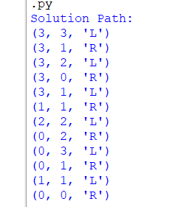
Result
The Missionaries and Cannibals Problem was successfully solved using Breadth-First Search (BFS). The program generated a valid sequence of states to safely transport all missionaries and cannibals across the river without violating the problem constraints.

